Demonstrate Platform as a Service (PaaS) create and configure a new VM Image in any Public Cloud Service Provider toget the Ubuntu Server 22.04 LTS

Home 

x

 Connect Start  Restart C] Stop Captu re Delete C_) Refresh Open in mobile Feedback cui / ps

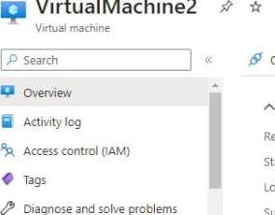

VirtualMachine2

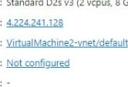

025

v3

vcpu$

8

Gig

memory)

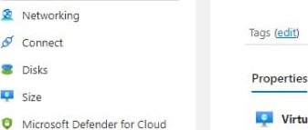

Properties

Essentials 'SON View

Resource group : iahnavi Operating system : Linux (ubuntu 22.04)

Status : Running

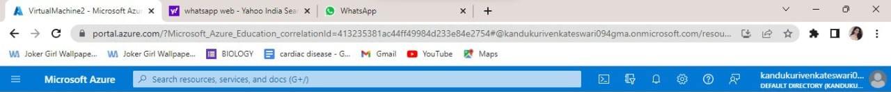 : Central India Public 'P address

Subscription : Azure-far-Studen.ts Virtual network/subnet

Subscription ID  DNS name

Settings

Health State

Monitoring Capabilities (7) Recommendations Tutorials

Virtual machine Networking

Computer name VirtualMachine2 Public IP address 4224241.128 ( Network virtualmachine2358 )

Advisor recommendations interface

Operating system Linux (ubuntu 22.04)